**Functional Flow**

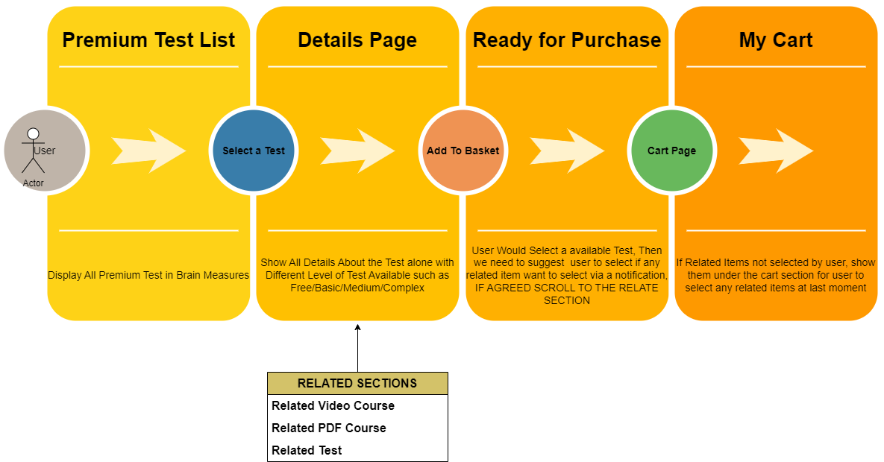

* User has a page to visit that shows details of Premium test features & list of test
* User has option to choose a test and see its details
* System will show related course on document, video and Test in the same page for user to select add-Ons
* In My Cart Page(Existing page), if the user already has related items added, then no change required, if no related items added, we need to show the related items and show the user an option to still select add ons before checkout to payment gateway.

**Hackathon Competition Flow**

* Admin Team Create a Competition on a particular test
* User’s register for the same test.
* All users are notified about the test 5 min before the start of the test
* Everybody takes the test and completes it on time.
* System will get the report of who is the winner and announce the list on time.

**Pages for hackathon**

1. New Hackathon with All Details
2. Registration Page
3. Result Page

**Landing Page Premium Test**

**https://www.hackerearth.com/challenges/**

Here all info of premium test Features

**1)Brainmeaurse, Programming Challenges, Competition**

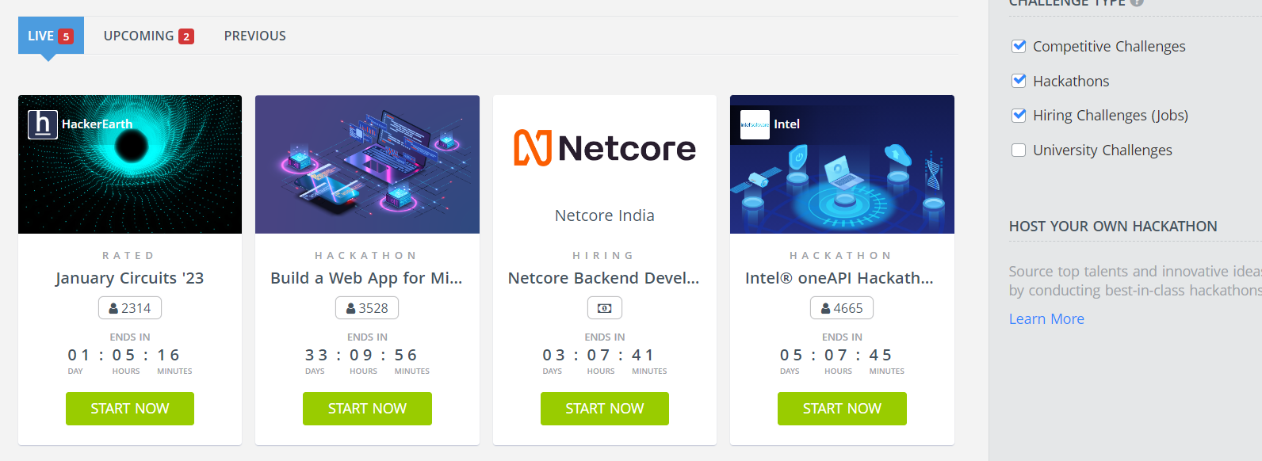

**2) Premium test List( random 10 tests)- More**

Here display the 10 premium test and link to separate premium tests Listing Page

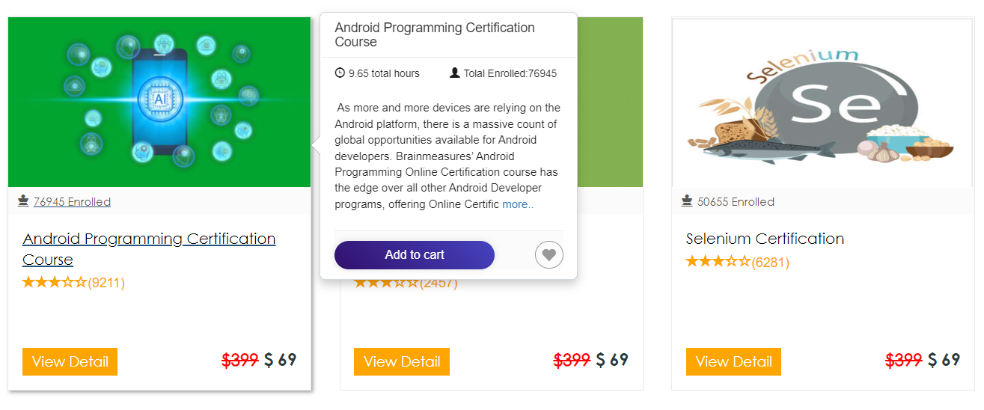

**3) Brainmeasures Diploma Test Certication**

Here display the 10 premium test and link to separate premium tests Listing Page



4)Practice Tests

**Detailed page of programming Challenge and Compettions**

[**https://www.hackerearth.com/challenges/new/competitive/january-circuits-23/**](https://www.hackerearth.com/challenges/new/competitive/january-circuits-23/)**?**

